**GSE PreCalculus *e-mail:*** Kelly.Avery@cobbk12.org

***Grading Policy****, Fall**Semester 2018*  ***blog:*** <https://averysprayberry.weebly.com/>

**Course Description**: This is the fourth course in a sequence of courses designed to provide students with a rigorous program of study in mathematics. It includes matrices, conics, introduction to trigonometry, graphs and inverses of trigonometric functions, trigonometric identities, vectors, laws of sine and cosine, and polar coordinates

**Supplies:**

1. **Notebook:** Organized 3-ring Folder/Binder – ordered by unit with notes/HW/skill checks, etc.

Notebooks will be checked at the end of each unit and count 2 HW grades

1. 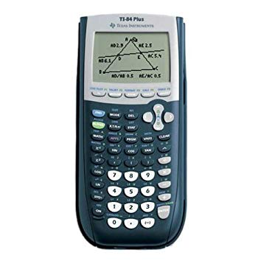**Pens/Pencils/Colored Pencils/Highlighers:** You may use pens for notes only. Keep on hand several sharpened pencils or mechanical pencils. Block erasers are also recommended. Colored pencils/Highlighters are optional, but are useful for graphs and shading.
2. **Graphing Calculator:** The TI-84 graphing calculator is strongly recommended for this class

**Grade Procedure:**

Tests 50% Quizzes 15% Homework 5% Midterm 10%

Projects 10% Final Exam 10%

##### Classroom Expectations

* **EVERYBODY** takes notes – stay focused, stay on task, be prepared, follow directions.
* **EVERYBODY** says please and thank you. Be respectful, be on time.
* **EVERYBODY** picks up trash.

Seek tutoring when you begin to struggle. *Follow the 5 Ps: prior planning prevents poor performance*

**Make-Up Work**

If you are absent, it is your responsibility to learn, obtain, and complete the work missed. Check the blog, email the teacher, or ask a classmate for the notes & missed work. *Students are allowed one day for each day of absence plus one additional day to make up work missed during absences.*

**Homework:**

**Homework will be assigned daily**. You will receive a grade for your percentage of completion or percentage correct. Although I encourage you to complete any unfinished homework, any incomplete homework grade will remain unchanged. No late work will be accepted.

**Cell Phones**

**Cell phones or other PEDs are not allowed in class unless allowed by the teacher as part of an assignment.** Refusal to put away your phone will lead to a written referral for insubordination.

Having a cell phone out during a graded assignment will be evidence of cheating.

**Help Sessions**

I’m the only teacher for GSE PreCalculus this semester. You may sign up for a PreCal AO on Tuesday and Thursdays, I will be the teacher. Additional help will have to be assigned by me.